**AI INTEGRATED WITH WATER MANAGEMENT SYSTEM**

A Project Report

submitted in partial fulfillment of the requirements

of

……………. Track Name ……

by

**Name of Student:B S KUBENDRAN**

**Email id: kubendrankubendran028@gmail.com**

**NM Id:D50D1829F5F8E1FAD65412ADF89F4EB1**

Under the Guidance of

**(P.Raja, Master Trainer, Edunet Foundation)**

**ACKNOWLEDGEMENT**

We would like to take this opportunity to express our deep sense of gratitude to all individuals who helped us directly or indirectly during this thesis work

I am really grateful and wish my profound indebtedness to Supervisor **P.RAJA** Deep Knowledge & keen interest of my supervisor in the field of Machine Learning to carry out this project. His endless patience, scholarly guidance, continual encouragement, constant and energetic supervision, constructive criticism, valuable advice, reading many inferior drafts and correcting them at all stages have made it possible to complete this project.

I would like to express my heartiest gratitude to **Mohamed Azarudheen**, Department of MECHANICAL, for his kind help to finish my project.

I would also generously welcome each one of those individuals who have helped me straightforwardly or in a roundabout way in making this project a win. In this unique situation, I might want to thank the various staff individuals, both educating and non-instructing, which have developed their convenient help and facilitated my undertaking.

Finally, I must acknowledge with due respect the constant support and patients of my parents.

**B S KUBENDRAN.**

**ABSTRACT**

Water management is one of the crucial topics discussed in most of the international forums. Water harvesting and recycling are the major requirements to meet the global upcoming demand of the water crisis, which is prevalent. To achieve this, we need more emphasis on water management techniques that are applied across various categories of the applications. Keeping in mind the population density index, there is a dire need to implement intelligent water management mechanisms for effective distribution, conservation and to maintain the water quality standards for various purposes. The prescribed work discusses about few major areas of applications that are required for efficient water management.

Water is one of the most essential resources for human survival. However, with the growing population and changing climate patterns, water scarcity has become a significant issue in many parts of the world. In this context, the development of a smart water management system using IoT technology has become a necessity. This paper presents an overview of the development of a smart water management system using IoT technology. The proposed smart water management system consists of several components such as sensors, communication devices, and a central server. The sensors are installed at various locations such as water sources, distribution networks, and consumer premises to collect data on water usage, quality, and availability. The collected data is transmitted to the central server through communication devices such as Wi-Fi, Zigbee, or Lora WAN. The central server processes the data and provides real-time information on water usage, quality, and availability. This information is then used to optimize the water distribution network and reduce wastage.

Those are recent trends in wastewater recycle, water distribution, rainwater harvesting and irrigation management using various Artificial Intelligence (AI) models. The data acquired for these applications are purely unique and also differs by type. Hence, there is a dire need to use a model or algorithm that can be applied to provide solutions across all these applications. Artificial Intelligence (AI) and Deep Learning (DL) techniques along with the Internet of things (IoT) framework can facilitate in designing a smart water management system for sustainable water usage from natural resources. This work surveys various water management techniques and the use of AI/DL along with the IoT network and case studies, sample statistical analysis to develop an efficient water management framework.

**TABLE OF CONTENTS**

Abstract:300

List of Figures:3

**Chapter 1. Introduction**

1.1Problem Statement

1.2Objectives

1.3Motivation

1.4. Scope of the Project

**Chapter 2. Literature Survey**

**Chapter 3. Proposed Methodology**

**Chapter 4. Implementation and Results**

**Chapter 5. Discussion and Conclusion**

**References**

**LIST OF FIGURES**

|  |  |  |
| --- | --- | --- |
| **Figure No** | **Name of the Figure** | **Page No.** |
|  | IOT BASED WATER MANAGEMENT SYSTEM | **12** |
|  | CONCEPT DIAGRAM | **14** |
|  | FLOWCHART | **15** |

**CHAPTER 1**

**INTRODUCTION**

Water management involves the tasks of conserving the water resources, harvesting the water, planning the available net water resources, and distributing it very appropriately to the consumers. It also involves setting up of policies and practices to execute the tasks under fragmented controls. The conventional methods and practices were found to be inadequate in executing the tasks effectively. Water management practices need to take full account so as to maintain the water resource sustainable over the long term. Nearly 97% of water is salty and not suited for drinking. The pollution also affects the available water. Several sectors like intensive agriculture [**1**], wastewater (UN-Water, 2011), mining, industrial production and untreated urban runoff are the major causes of water pollution. Water from various sources needs to be utilized in an efficient manner which lacks in traditional water management methods. The existing methods for water usage are not so cost-effective [**2**], and there is also a disinclination towards implementing the latest information and communication technologies (ICT). The machine learning algorithms have the potential to expand the learning process in an exponential manner with a specific target. Standard algorithms would not scale exponentially to cover undiscovered patterns in the new data sets. Water management is required in the areas such as agriculture, public supply, industry, mining, generating hydro power, aqua culture and livestock hood. In agriculture, the key challenges are with respect to water access methods, efficient use of water and sustainable practices to conserve and harvest water. In India, industries are the second highest consumers of water as well as one of the highest source of pollutants. The industries take the water from ground water or surface water. The choice of the selection depends upon various factors like ground water availability, surface water availability, cost and demand of the fresh water from the municipal corporation. The demand for the water by the industries/factories/mining keeps growing on par with the increase in urbanization. Simultaneously, there is an increase in wastewater disposal without treating it appropriately into the natural sources, which is again also polluting the unpolluted water. Due to the lack of adequate water management policies, effective monitoring methodologies need to be devised for the industries to maintain a storage treatment plant (STP) and use this treated water for their purpose. Prolonged drought is also a major issue faced by the general public in the metropolitan cities. Managing the water supply during water shortage season is one of the demanding tasks by the officials of the metropolitan water board. This is the challenge that paved the way for the intervention of intelligent techniques. The water distribution infrastructure modelled by the smart algorithms supports efficient distribution of safe and sustainable water supply to the general public. The model built with intelligent techniques would recommend smart appliances which would utilize less water, impose restriction towards the amount of water usage at homes and apply tariffs for water usage. The quality of the water is assessed by three classes of attributes: physical, biological and chemical. Some of the quality indicators (pollutants) of water include chlorophyll, pH, dissolved oxygen, heavy metal contents, chloride and lead. There are a few researchers who use location and elevation of water bodies as inputs into various machine-learning approaches to forecast pollution [**3**]. The intelligent systems such as IoT, deep learning [**4**] and machine learning algorithms could be harnessed towards the process like leak management, flow monitoring, overuse, contamination and devising strategies towards acceptable water use (**Figure 1**). This paper aims to bring to the forefront compelling new opportunities for intelligent techniques intervening to address the major challenges faced in water management.

* 1. **PROBLEM STATEMENT:**
* Water scarcity and inefficient water usage are growing concerns in both urban and rural areas, exacerbated by factors such as climate change, population growth, and inadequate infrastructure. Traditional water management systems are often reactive, relying on manual monitoring, scheduled irrigation, and static water distribution methods. These systems fail to dynamically adapt to real-time changes in water demand, environmental conditions, and consumption patterns, leading to waste, inefficiency, and, in some cases, water shortages.
* The challenge is to design an AI-integrated smart water management system that optimizes water usage, improves distribution efficiency, and ensures sustainability. The system should leverage real-time data, predictive analytics, and machine learning to automate and intelligently control various aspects of water management, such as consumption monitoring, leak detection, demand forecasting, and resource allocation.
  1. **OBJECTIVES:**
* **1.** Real-Time Monitoring: Implement sensors and IoT devices to continuously collect data on water usage, quality, and environmental conditions (e.g., rainfall, soil moisture).
* **2.** Predictive Analytics: Use AI algorithms to forecast water demand and identify potential shortages or excesses, enabling proactive adjustments.
* **3.** Leak Detection and Prevention: Employ machine learning models to identify anomalies and detect leaks or inefficiencies in the water distribution network before they cause significant damage or wastage.
* **4.** Automated Water Distribution: Develop an AI-driven control system that can autonomously regulate water distribution, adjusting supply based on real-time demand and availability.
* **5.** Sustainability and Conservation: Provide insights into best practices for water conservation and enable optimized irrigation scheduling to reduce water waste, especially in agriculture.
* **1.3 MOTIVATION:**
* Water is one of the most vital natural resources, yet it remains a finite and often mismanaged resource. With the global population continuing to rise, urbanization expanding, and climate change altering precipitation patterns, the demand for clean water has reached unprecedented levels. Simultaneously, water scarcity, pollution, and inefficient usage continue to worsen. Traditional methods of water management, often reactive and manually controlled, are no longer sufficient to address the modern challenges surrounding water conservation, equitable distribution, and sustainability.
* Key Motivating Factors:

1. Rising Water Scarcity: According to the United Nations, over two billion people live in countries experiencing high water stress, and that number is expected to grow as global populations increase. Inefficient water distribution and overuse in agriculture, industry, and urban areas exacerbate this issue. AI can help monitor, predict, and optimize water usage, ensuring water resources are allocated efficiently.
2. Increased Urbanization and Population Growth: Rapid urbanization and population growth place significant pressure on existing water infrastructure. AI-integrated systems can dynamically manage water demand in urban environments, optimizing distribution networks to prevent water shortages, leaks, and waste.
3. Water Waste and Leakage: Significant portions of water are lost due to leaks in aging infrastructure or inefficient irrigation methods. An AI-based system can automatically detect leaks, predict potential points of failure, and suggest timely maintenance or adjustments to avoid wastage.
4. Climate Change and Unpredictable Weather Patterns: Climate change is causing more erratic weather patterns, with regions experiencing severe droughts, flooding, and unpredictable rainfall. AI can analyze vast amounts of climate data to forecast these patterns, enabling better water resource planning and helping mitigate risks of both scarcity and overflows.
5. Agriculture and Irrigation Efficiency: Agriculture consumes about 70% of the world’s fresh water, much of it through inefficient irrigation practices. AI can enable precision irrigation based on real-time soil moisture, weather data, and crop needs, reducing water consumption while maximizing agricultural output.
6. Sustainability and Environmental Impact: Over-extraction of water from natural sources, coupled with pollution, can have long-term detrimental effects on ecosystems. AI systems can be used to monitor water quality and ensure that water usage remains within sustainable limits, preserving ecosystems and maintaining biodiversity.
7. Cost Efficiency: Traditional water management systems often rely on outdated, manual methods for monitoring and controlling water use. These systems are labor-intensive, error-prone, and inefficient. By incorporating AI and machine learning, water management can become more cost-effective, with predictive algorithms identifying and addressing issues before they escalate, saving both time and money.

* **SCOPE OF THE PROJECT:**
* The AI-Integrated Smart Water Management System has the potential to revolutionize the way water resources are managed, enabling efficient, sustainable, and equitable distribution. The system would incorporate various cutting-edge technologies like artificial intelligence (AI), machine learning, the Internet of Things (IoT), data analytics, and sensor networks to monitor, manage, and optimize water usage across different sectors. Below is an outline of the system's scope in terms of its functionality, potential applications, and impact areas:

1. Real-Time Water Monitoring and Data Collection
2. Predictive Analytics for Demand Forecasting
3. Automated Water Distribution and Supply Management
4. Leak Detection and Fault Diagnosis
5. Smart Irrigation Systems for Agriculture
6. Water Recycling and Reuse Optimization
7. Water Quality Monitoring and Management
8. Climate Change Adaptation and Resilience
9. Water Usage Monitoring and Consumer Behavior Analysis
10. Policy and Decision Support Systems



**CHAPTER 2**

**LITERATURE SURVEY**

This paper presents the design and implementation of a smart water management system using IoT technology. The system includes a wireless sensor network, a cloud platform, and a mobile application. The system allows real-time monitoring and control of water usage, and it provides users with personalized recommendations for water conservation.

1. This paper proposes a smart water management system based on IoT and cloud computing. The system uses wireless sensors to collect data on water usage, and the data is stored and analyzed on a cloud platform. The system provides real-time feedback to users on their water usage and suggests ways to conserve water
2. This paper presents an IoT-based smart water management system using Raspberry Pi. The system includes sensors for monitoring water usage and a Raspberry Pi for data processing and control. The system provides real-time feedback to users on their water usage and enables remote control of water usage through a mobile application.
3. This paper presents the design of a smart water management system based on IoT. The system includes sensors for monitoring water usage, a data transmission module, and a cloud platform for data storage and analysis. The system enables real-time monitoring and control of water usage and provides users with personalized recommendations for water conservation.
4. This paper proposes a smart water management system using IoT and big data. The system includes sensors for monitoring water usage, a cloud platform for data storage and analysis, and a mobile application for user feedback. The system provides real-time feedback to users on their water usage and suggests ways to conserve water based on big data analysis.
5. This paper presents a smart water management system using IoT and machine learning. The system includes sensors for monitoring water usage, a cloud platform for data storage and analysis, and a machine learning algorithm for predicting water usage patterns. The system provides real-time feedback to users on their water usage and suggests ways to conserve water based on machine learning predictions.
6. This paper presents an IoT-based water management system that uses sensors to monitor soil moisture, temperature, and humidity to improve irrigation efficiency in precision agriculture. The system uses cloud-based data analytics to optimize water usage and reduce wastage.[7]
7. This paper presents a smart water management system based on IoT that uses a network of sensors and actuators to monitor water usage and control the flow of water in a building. The system can be controlled remotely through a mobile application, and it helps in reducing water wastage.[
8. This paper reviews various smart irrigation systems based on IoT technology and discusses their advantages and limitations. The authors suggest that the integration of sensor networks with cloud-based data analytics can help in the efficient management of water resources in agriculture.
9. This paper presents an IoT-based smart water quality monitoring system that uses sensors to monitor water quality parameters such as pH, dissolved oxygen, and temperature. The system sends real-time data to a cloud-based server, which can be accessed through a mobile application.
10. This paper presents a smart water management system that uses IoT technology and machine learning algorithms to predict water demand and optimize water usage. The system uses historical data to train the machine learning model, which can predict water demand accurately.
11. This paper presents an IoT-based smart water distribution system that uses a network of sensors and actuators to monitor and control the flow of water in a distribution network. The system can detect leaks and reduce water wastage.
12. This paper presents an IoT-based smart water metering system that uses sensors to measure water consumption and sends real-time data to a cloud-based server. The system can help in reducing water wastage and improving billing accuracy.

**CHAPTER 3**

**PROPOSED METHODOLOGY**

The management of water resources is an essential aspect of sustainable development, and it is critical to the success of many industries, such as agriculture, energy, and urbanization. Due to the increasing demand for water resources, the need for efficient and smart water management systems is becoming more important. The Internet of Things (IoT) technology is a suitable solution to tackle the issue of water management. This proposed system aims to develop a smart water management system using IoT technology to address the water scarcity problem.

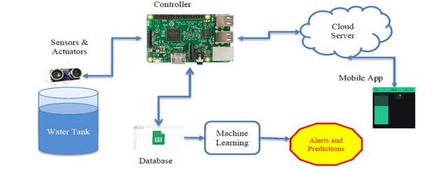

**FIG1.1: IOT BASED WATER MANAGEMENT SYSTEM**

**Background:**

Water scarcity is a significant problem in many parts of the world, and it is expected to increase with the rise in population and economic growth. The traditional water management systems are not efficient enough to handle the increasing demand for water. There is a need for smart water management systems that can provide real-time data and optimize the water distribution process. The Io T technology is a suitable solution to address the issue of water management. Io T is a network of devices that are connected to the internet and can communicate with each other. These devices can collect and transmit data to a central system, allowing for real-time monitoring and control of various systems. Io T technology has been successfully applied in various sectors such as health care, transportation, and manufacturing. The proposed system is a smart water management system that utilizes Io T technology to provide efficient water management. The system consists of various sensors, communication devices, and a central system that collects and analyzes data. The following are the components of the proposed system: Sensors: The system will have various sensors installed in the water supply network, such as water flow meters, pressure sensors, and water quality sensors. These sensors will collect data in real-time and transmit it to the central system. Communication Devices: The sensors will be connected to the communication devices such as Wi-Fi, cellular, or satellite networks. The data collected by the sensors will be transmitted to the central system through these communication devices. Central System: The central system will receive the data transmitted by the sensors and analyze it to provide insights into the water supply network. The system will use machine learning algorithms to predict the demand for water and optimize the distribution process. This system can collect data from various sources, analyse it, and provide valuable insights to improve water management. This paper discusses the design and implementation of a smart water management system using Io T technology.

**CHAPTER 4**

**IMPLEMENTATION AND RESULT**

The implementation of the AI-Integrated Smart Water Management System involves the deployment of IoT sensors across water distribution networks, treatment plants, and agricultural fields, along with a cloud-based platform for real-time data processing and analysis. These sensors monitor key parameters such as water quality, flow rates, pressure, and consumption, which are then aggregated and analyzed by machine learning models. The AI-driven system predicts water demand, optimizes distribution, detects anomalies like leaks, and adjusts water usage dynamically based on real-time conditions.

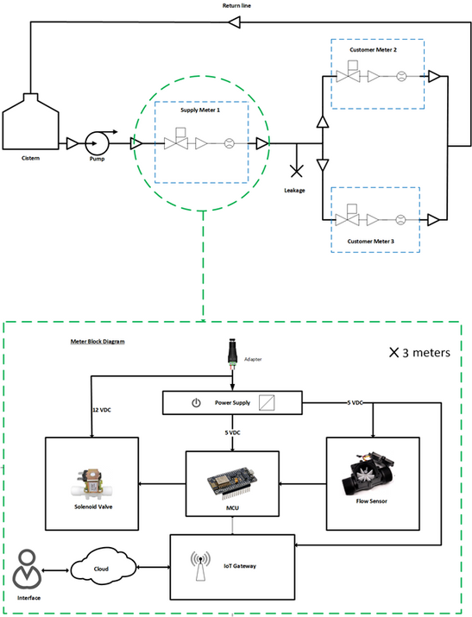

**FIG.2: CONCEPT DIAGRAM**

In agriculture, the system enables precision irrigation by analyzing soil moisture and weather data, reducing water wastage. During deployment, the system undergoes a pilot phase to test its performance in real-world scenarios, collecting baseline data and refining AI models for demand forecasting, leak detection, and water quality monitoring. Once fully deployed, the system offers improved water conservation, reduced operational costs, and enhanced efficiency in water management. The results include a significant reduction in water wastage, faster response times to leaks and infrastructure issues, better resource allocation, and more sustainable practices, especially in water-scarce regions. By providing actionable insights to both utilities and consumers, the system promotes water-saving behaviors and ensures equitable, reliable access to water.

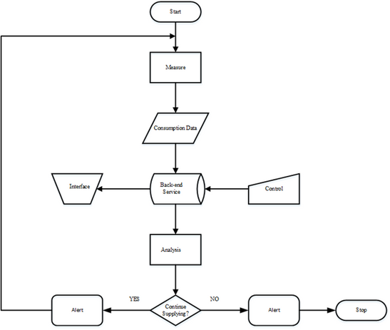

**FIG.3: FLOWCHART**

**CHAPTER 5**

**DISCUSSION AND CONCLUSION**

* **5.1.GIT HUB LINK OF THE PROJECT:**
* **5.2. LIMITATIONS:**

1. Data Dependency and Quality
2. High Initial Costs
3. Complexity of Integration
4. Scalability Issues
5. Data Privacy and Security
6. Dependence on Human Oversight
7. Lack of Standardization
8. Environmental Variability
9. Ethical and Social Impacts

* 10. Ongoing Maintenance and Adaptation
* **5.3. CONCLUSION:**
* Water utilities worldwide are undergoing a digital transformation,
* driven by the internet, big data, and AI algorithms. To remain competitive and improve customer service delivery, water utilities need to shift from an “old school” operation, as a result of operating a monopoly with little external pressure, or Hydraulic Modeling 1.0, to a new era of efficiency and accountability, or Hydraulic Modeling 2.0. The availability of affordable big data from sensors, customers, and staff drives this transformation. Access to information is not knowledge, as big data needs to be processed further for operational and planning decisions. Artificial intelligence algorithms help the water utility to become more data-efficient by transforming information into a leaner operation, boosting data-driven decision making through a combination of AI numerical tools and human operational skills.Such digital transformation
* to become a “smart” water utility goes beyond the technical challenge of integrating data, but also requires a new organization structure, and new sets of operational procedures with buy-in from the staff and the consumers. A new set of national and sector policies is needed to support this digital transformation of the water sector; specifically, to improve governance resulting from the organizational restructuring and enhanced regulation for cost-effective implementation.
* Most water utilities start their digital transition with a SCADA linked to a network control center; then figure out how to turn these ICT investments into real benefits. As a result, the digital capacities of many water utilities, particularly in developing countries, are not so useful for day-to-day operations and do not bring a clear benefit to the customers. The digital transition of water utilities should be progressive, pragmatic, and target-oriented.
* This brief presented the current trends in application of advanced technologies and techniques, especially AI algorithms, in water supply in general and for the prognosis of UFW in particular. Even though there are many AI tools for many different applications, the most promising ones for water distribution network analysis and UFW estimation are those based on a combination of physically based and data-driven models. Physically based methods are the way forward for water utilities to start their digital transformation into smart water.

**REFERENCES**

1. Li, Y., Chen, W., & Li, Z. (2014). Design and implementation of a smart water management system based on IoT technology. Journal of Sensors, 2014, 1-7.
2. Wu, C. Y., Lu, C. Y., & Li, Y. C. (2015). A smart water management system based on IoT and cloud computing. Journal of Sensors, 2015, 1-8.
3. Mohamed, N., & Abdelsalam, H. (2015). IoT based smart water management system using raspberry pi. International Journal of Computer Science and Mobile Computing, 4(3), 291- 296.
4. Tao, X., Cui, J., Zhang, W., & Wang, J. (2015). Design of a smart water management system based on IoT. Journal of Physics: Conference Series, 642(1), 012024.
5. Kim, S. H., Kim, S. H., Lee, S. Y., & Lee, W. J. (2016). Design and implementation of a smart water management system using IoT and big data. Journal of Sensors, 2016, 1-8.
6. Yoon, J. K., Kim, H. S., & Kim, H. S. (2016). A smart water management system using IoT and machine learning. Journal of Sensors, 2016, 1-7.
7. N. Zhang et al. "An IoT-based water management system for precision agriculture" (2015)
8. S. Saha et al. "Smart water management system based on IoT" by (2017)
9. R. Gupta et al. "A review of smart irrigation systems based on IoT" by (2016)
10. S. Arora et al. "IoT-based smart water quality monitoring system" by (2016)

* [11] A. Jain et al. "Smart water management system using IoT and machine learning" by A. Jain et al. (2017)
* [12] S. Singh et al. "IoT-based smart water distribution system" by (2017)
* [13] L. Wang et al., "Design and implementation of an IoT-based smart water metering system" by (2016)
* [14] J. Wang et al., "A smart water quality monitoring system based on IoT and WSN" by (2016)
* [15] S. Mondal et al., "IoT-based smart irrigation system for sustainable agriculture" by (2017)
* [16] M. Chowdhury et al., "Smart water management system for sustainable urban development" by (2017